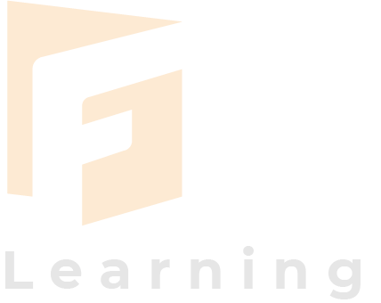
Instructional Design Document – With DT
Topic name: From Source to Sanitation: Designing Sustainable Water Futures
Date: 08 March 2026
Class: 11th Grade
Faculty name: Mindspark

Topic context:
Purpose | To enable students to understand the scientific, environmental, social, and sanitation and apply interdisciplinary thinking to develop sustainable and practical water management solutions.
objectives | Students will be able to:  - Explain the natural and human-managed water cycle.  - Identify factors affecting freshwater availability and distribution.  - Analyze the relationship between water quality, sanitation systems, and public health.  - Evaluate global and local water management strategies.  - Design sustainable and scalable sanitation solutions considering environmental, social, and economic constraints.
Learning descriptions:
Pre-requisite | Students should have basic knowledge of:  - The water cycle  - Ecosystems and environmental science  - Basic microbiology related to water contamination  - Fundamental public health concepts
Learning environment | - Interactive classroom with multimedia presentations  - Group discussion and collaborative learning  - Access to case studies, maps, and water quality datasets  - Digital tools for concept mapping and solution design  - Possibility of virtual or real field exposure to water treatment systems (Visit to STP/ETP plants)
Design specifications :
Performance goals | Students should be able to:  - Analyze water-related problems using scientific and social perspectives  - Work collaboratively to design sustainable sanitation systems  - Evaluate the feasibility and scalability of proposed solutions  - Communicate solutions through presentations, reports
Learning outcomes | By the end of the session students will:  - Understanding of water systems and sanitation technologies.  - Explain how water quality impacts human health and ecosystems.  - Evaluate water management challenges from technical and social perspectives.  - Develop practical water and sanitation solutions suited to real-world contexts.  - Integrate environmental sustainability and community needs into their designs.
Delivery methods | - Interactive lecture with visuals  - Concept mapping of water systems  - Case study analysis  - Group discussion and debates  - Design-thinking workshop  - Infographic or model creation  - Short documentary/video analysis
Assessment type | Formative assessment:  - Classroom discussions  - Concept maps  - Short quizzes  Summative assessment:  - Group project on sustainable water solutions  - Written reflection or analytical report
Assessment level | - Knowledge: Understanding water cycle and sanitation concepts  - Application: Analyzing real-world water problems  - Analysis: Evaluating water management strategies  - Synthesis: Designing sustainable sanitation solutions  - Evaluation: Assessing feasibility and social impact of solutions

The major hurdle module you face while applying VGG 16 model is
- Requirement of large labelled datasets for accurate training
- High computational cost and GPU requirements
- Risk of overfitting when dataset size is small
- Difficulty in fine-tuning deep layers for domain-specific environmental images
- Long training time and memory consumption

